**SUPERSET 6413403**

**Exercise 7: Financial Forecasting (Recursive Algorithm)**

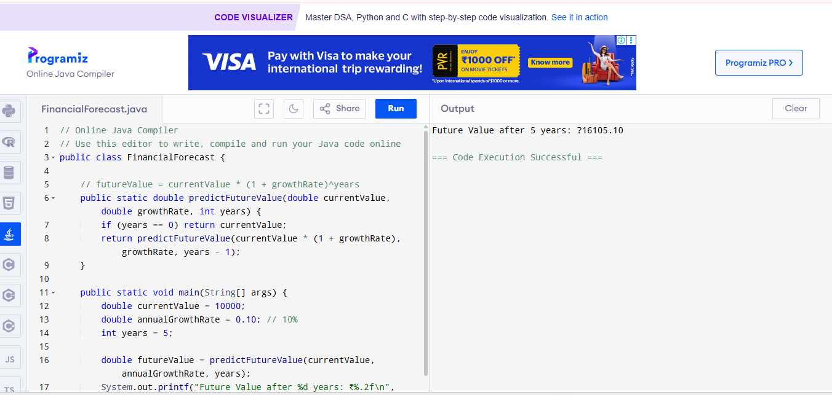

**Java Code (Recursive Growth)**

public class FinancialForecast {

// futureValue = currentValue * (1 + growthRate)^years

public static double predictFutureValue(double currentValue, double growthRate, int years) {

if (years == 0) return currentValue;

return predictFutureValue(currentValue * (1 + growthRate), growthRate, years - 1);

}

public static void main(String[] args) {

double currentValue = 10000;

double annualGrowthRate = 0.10; // 10%

int years = 5;

double futureValue = predictFutureValue(currentValue, annualGrowthRate, years);

System.out.printf("Future Value after %d years: ₹%.2f\n", years, futureValue);

}

}

**Sample Output**

Future Value after 5 years: ₹16105.10